**Practical-1**

**Aim: Write a C Program to print the below design using printf function with help of \t & \n escape sequence(please check below the image in attachment section).**

**Program:**

#include<stdio.h>

#include<conio.h>

main()

{

clrscr();

printf("\t\t*\t\t*\n");

printf("\t*\t\t*\t\n");

printf("*\t\t*\t\t\n");

printf("\t*\t\t*\t\n");

printf("\t\t*\t\t*\n");

getch();

}

**Output:**

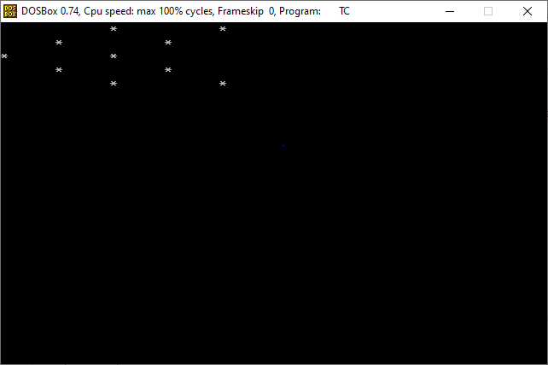

**Program:**

#include<stdio.h>

#include<conio.h>

main()

{

clrscr();

printf("\t*\t*\t*\t*\t*\t*\t*\n\n");

printf("*\t*\t*\t*\t*\t*\t*\t*\n");

printf("*\t\t*\t\t\t\t\t*\n");

printf("*\t\t*\t\t*\t*\t*\t*\n");

printf("*\t\t*\t\t*\t\t*\t*\n");

printf("*\t*\t*\t*\t*\t*\t*\t*\n");

getch();

}

**Output:**

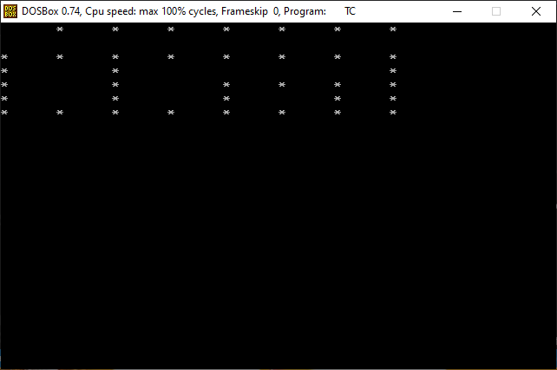

**Aim: Write a C Program to perform a swapping of two variables.**

**Program:**

#include<stdio.h>

#include<conio.h>

main()

{

int i,j,temp;

clrscr();

printf("=> Enter the value of i :- ");

scanf("%d",&i);

printf("=> Enter the value of j :- ");

scanf("%d",&j);

temp=i;

i=j;

j=temp;

printf("\n i => %d\n j => %d",i,j);

getch();

}

**Output:**

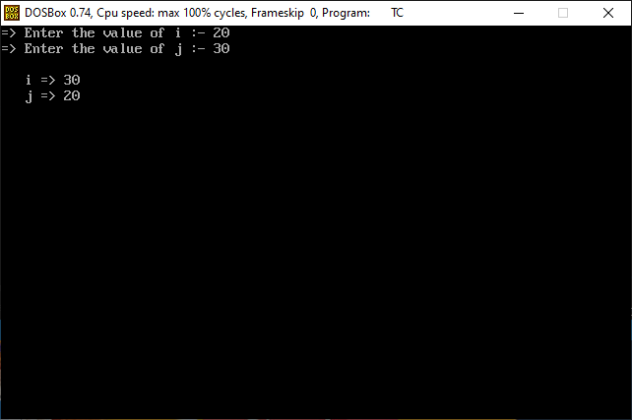

**Aim: Write a C program to convert temperature from degree Celsius to Fahrenheit.**

**Program:**

#include<stdio.h>

#include<conio.h>

main()

{

float cel,fer;

clrscr();

printf("=> Enter a celcius :- ");

scanf("%f",&cel);

fer=(cel*9/5)+32;

printf("\n=> Convert into fahrenhit :- %.2f",fer);

getch();

}

**Output:**

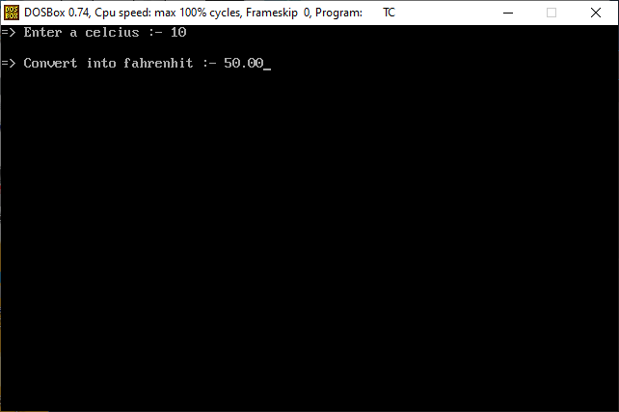

**Aim: Write C Program to find gross salary.**

**Ex. Base Salary: 100 RS, HRA=10%, DA=5%, TA=8%.**

**Ans = 123 RS**

**Program:**

#include<stdio.h>

#include<conio.h>

main()

{

int salary,sum;

float hra,da,ta;

clrscr();

printf("=> How many salary :- ");

scanf("%d",&salary);

hra=0.1*salary;

printf("=> Salary wise HRA :- %.2f\n",hra);

da=0.05*salary;

printf("=> Salary wise DA :- %.2f\n",da);

ta=0.08*salary;

printf("=> Salary wise TA :- %.2f\n",ta);

sum=salary+hra+da+ta;

printf("\n=> Total salary :- %d",sum);

getch();

}

**Output:**

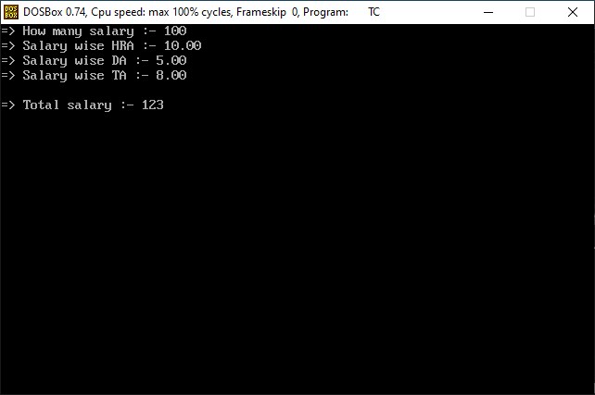

**Aim: Write a C Program to convert kilometer in miles and vise verse based on user input.**

**Program:**

#include<stdio.h>

#include<conio.h>

main()

{

float km,miles;

clrscr();

printf("=> Enter a kilometer :- ");

scanf("%f",&km);

miles=km*0.62;

printf("\n=> Convert into miles :- %.2f",miles);

getch();

}

**Output:**

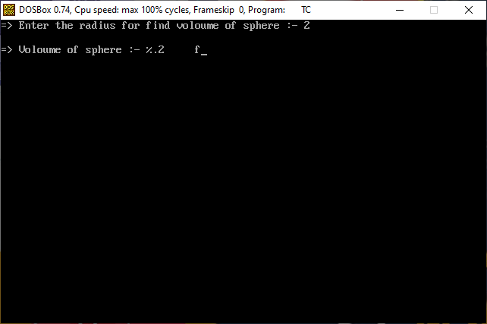

**Aim: Write a C program that calculates the volume of a sphere.**

**Program:**

#include<stdio.h>

#include<conio.h>

#define PI 3.14

main()

{

float r,sum;

clrscr();

printf("=> Enter the radius for find voloume of sphere :- ");

scanf("%f",&r);

sum=(4*PI*r*r*r)/3;

printf("\n=> Voloume of sphere :- %.2f",sum);

getch();

}

**Output:**



**Aim: Write a C program that takes hours and minutes as input, and calculates the total number of minutes.**

**Program:**

#include<stdio.h>

#include<conio.h>

main()

{

int hour,min,sum;

clrscr();

printf("=> How many hour :- ");

scanf("%d",&hour);

printf("=> How many min :- ");

scanf("%d",&min);

sum=(hour*60)+min;

printf("\n=> Total number of min :- %d",sum);

getch();

}

**Output:**

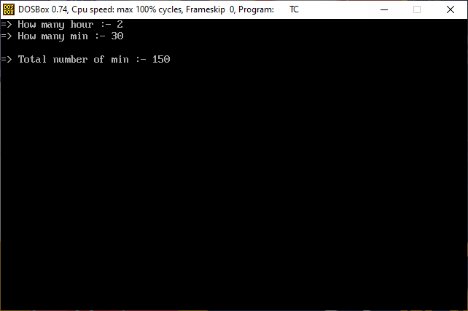

**Aim: Write a C program to find the third angle of a triangle if two angles are given.**

**Expected Output:**

**Input two angles of triangle separated by comma : 50, 70**

**Third angle of the triangle : 60**

**Program:**

#include<stdio.h>

#include<conio.h>

main()

{

int first,second,third;

clrscr();

printf("=> Enter first angle for tringle :- ");

scanf("%d",&first);

printf("=> Enter second angle for tringle :- ");

scanf("%d",&second);

third=180-(first+second);

printf("\n=> Third angle of tringle :- %d",third);

getch();

}

**Output:**

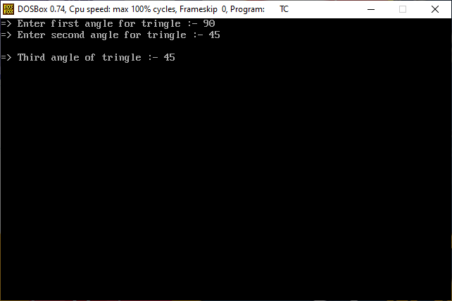

**Aim: Write a C program to find velocity of given speed and time.**

**Program:**

#include<stdio.h>

#include<conio.h>

main()

{

int v,s,d,t;

clrscr();

printf("=> Enter a speed for find velocity :- ");

scanf("%d",&s);

printf("=> Enter a time for find velocity :- ");

scanf("%d",&t);

d=s*t;

v=d/t;

printf("\n=> Velocity :- %d",v);

getch();

}

**Output:**

